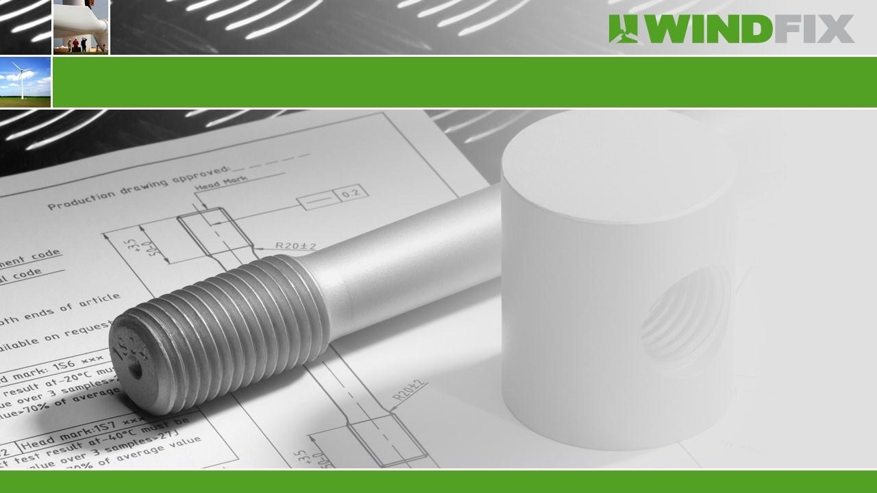
Wind
-
Fix
P
resentation

Member of

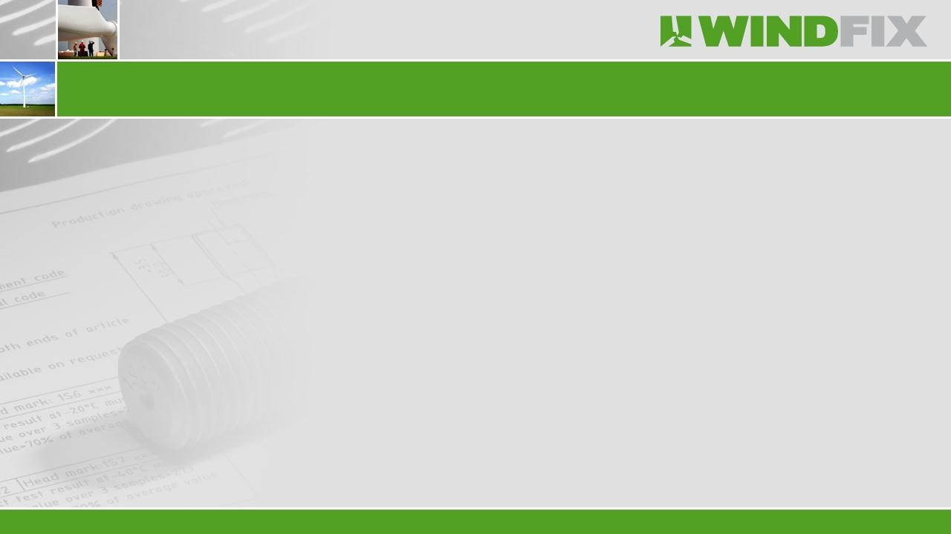




Founded in 1988 as a trading company in stainless steel fasteners.

Multi
-
Fix Group consists of 2 companies with approximately 90 employees.

Turnover
€

,
17.000.000
-

Euro in 2014.

Fasteners: Mechanical fasteners and related products.

Specials: Customized metal components and assemblies.

Solar
:
Components and mounting systems for solar
energy.

Wind
-
Fix: Components for wind turbines.

Key

figures

Multi
-
Fix Group

Business
Scope
:

Connectors for
wind
and hydraulic turbines and
related
metal and
plastic
components.

Producer
and

supplier

of European
quality

blade

connectors

and

high
s
trength

fasteners
.

Head
office in The
Netherlands (
Bergeijk
and subsidiary
)
in
China (Shanghai).

ISO
9001
accredited
and
GL
Prüfung
.

Customers such as LM,
Suzlon
, GE, JSW and
Vestas
.

Key

figures

Wind
-
Fix

Wind
-
Fix has a complete range of products like:

•
Inserts

•
Barrel /
Cylindrical

nuts

•
Studs

•
Foundation studs

•
Thread rods

•
High
strength

bolts
,
high
strength

nuts
and

h
igh
strength

washers

•
Din

6914
/
Din

6915
/
Din

6916

Products

Several finishing's / surface treatment:

•
Delta MKS coating

•
Dacromet

/
Geomet

•
Hot dip galvanizing

•
Phosphating

or
phosphatizing

•
Zink plating

•
Sherardising

or
vapour

galvanising

Products

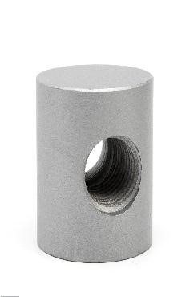
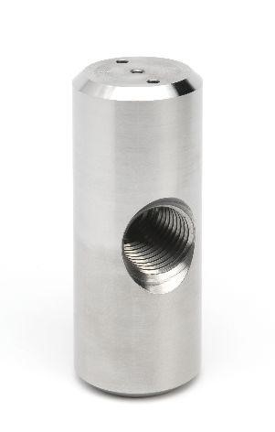
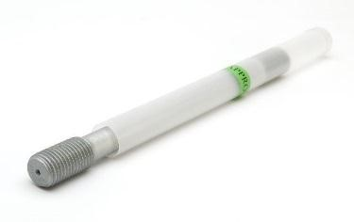
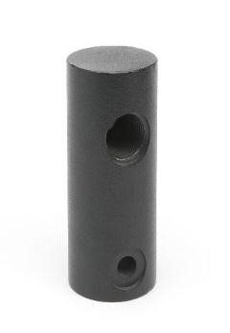
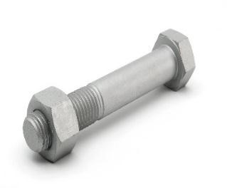
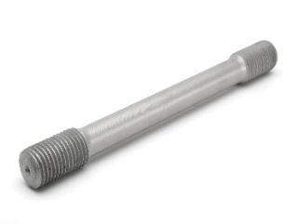
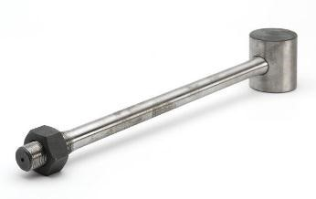
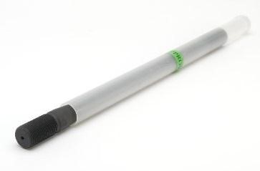
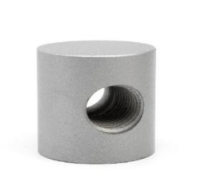
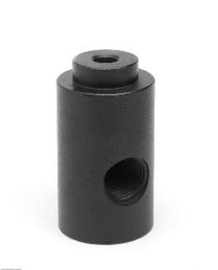
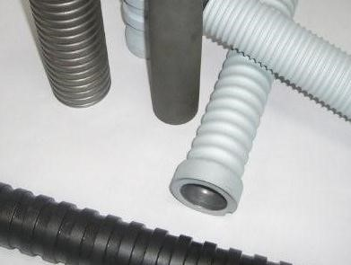
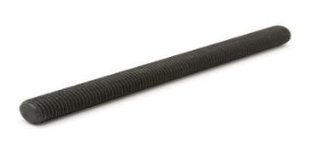
Products

Production
facility in
Shanghai:

•
CNC
c
entres

•
CNC machines

•
NC machines

•
Sawing machines

•
Drilling machines

•
Thread tapping and thread rolling

•
Capacity up to 200 Tons of raw material per month

Production

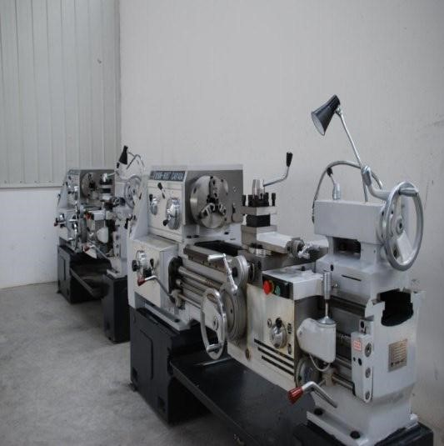
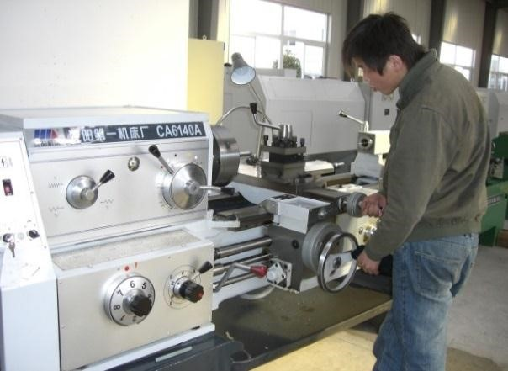
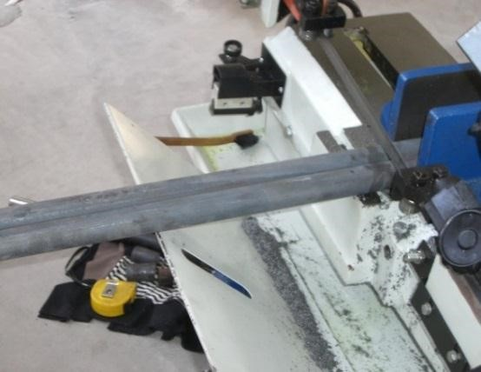
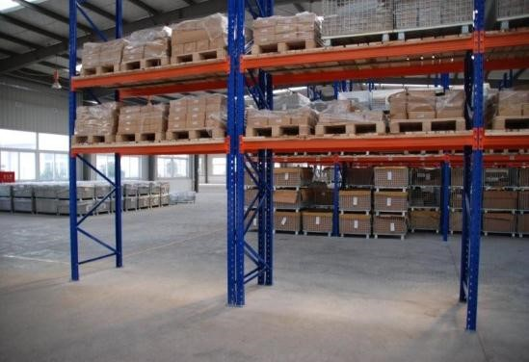
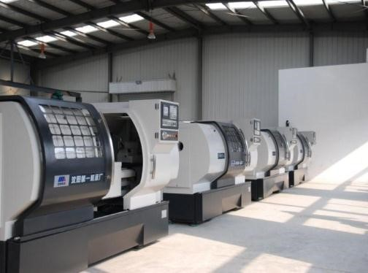
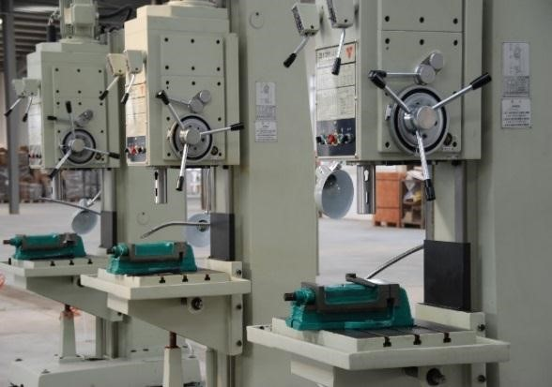
Production

and

W
arehousing

Germanischer

Lloyd’s accredited Laboratory:

•
Mechanical analysis

•
Tensile strength (up to 200 tons pulling machine)

•
Yield strength

•
Elongation

•
Hardness

•
Impact value test (up to
-
60
°

C)

•
Chemical material analyses

•
Ultrasone

testing and MT
-
testing

•
Salt spray
testing

•
Microscope inspections

Quality

Control

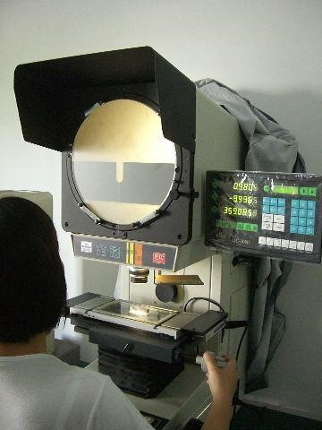
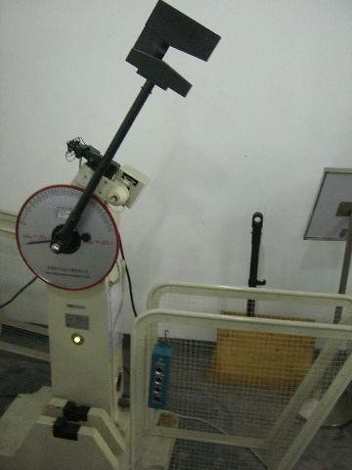
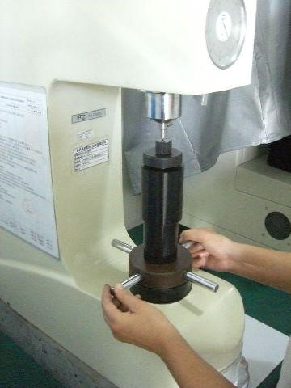
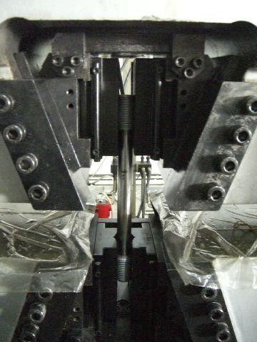
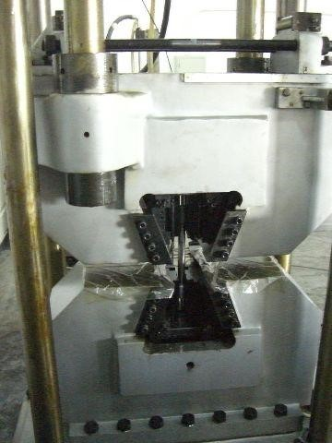
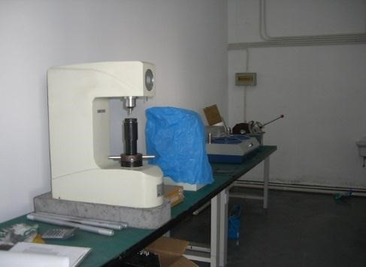
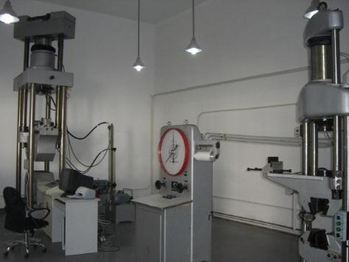
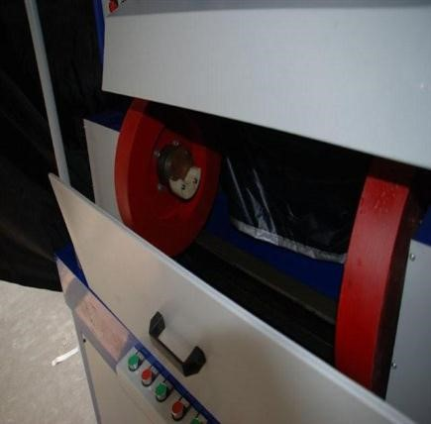
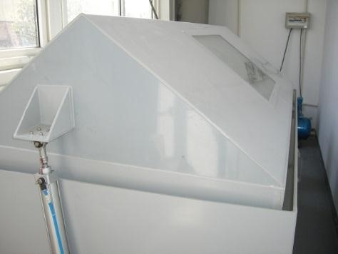
Quality

Control

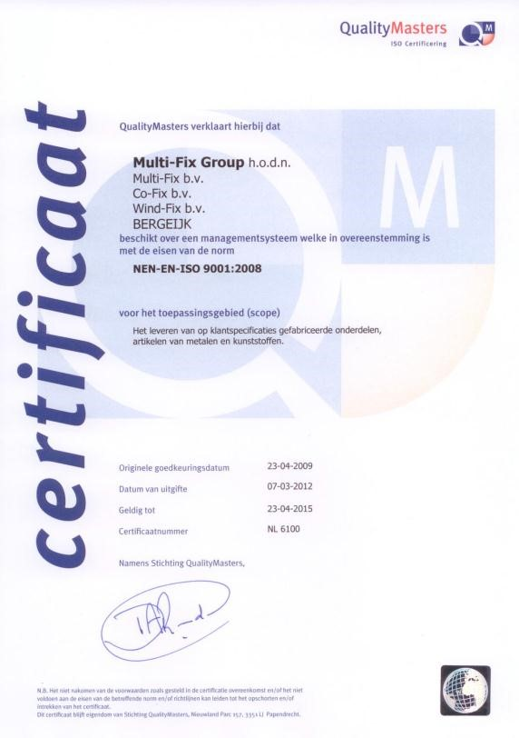
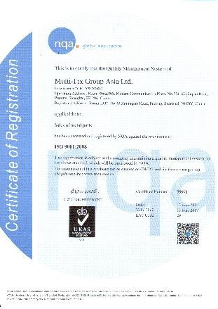
Quality Management

Wind
-
Fix Europe
BV

Member of Multi
-
Fix Group BV

P.O. Box 93

5570
AB
Bergeijk

Bokkerijder

24
-
26

5571
MX Bergeijk

Netherlands

T. +31 497 55 29 29

F. +31 497 55 29 55

www.multifixgroup.co
m

